ACTIONS


Grade 5
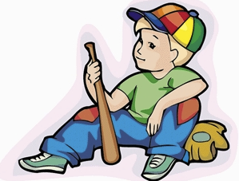

Name : __________________

Group : _________________
Commission scolaire de Saint-Hyacinthe
Acknowledgements to Sylvie Fortier and Hélène Laforest – 2012
Conseillère pédagogique Tanja Vaillancourt

Series 1 (regular verbs)

Ask (inf.)
Asked (past)

Explain
Explained

Erase
Erased

Listen
Listened

Play
Played

Talk
Talked

Watch
Watched

Walk
Walked

Scream
Screamed

Want
Wanted

Work
Worked

Whisper Whispered

Practice your verbs

________________________________________________________________________________________________________________________________________________________________________________________________________________________________________________________________________________________________________________________________________________________________________________________________________________________________________________________________________________________________________________________________________________________________________________________________________________________________________________________________________________________________________________________________________________________________________________________________________________________________________________________________________________________________
Series 2 (irregular verbs)

Come (inf.)
Came (past)

Drink
Drank

Drink (inf.)
Drank (past)

Do
Did

Eat
Ate

Go
Went

Lose
Lost

Stand Up
Stood up

Stand up
Stood up

Say
Said

Sit down
Sat down

Win
Won

Write
Wrote

Find
Found

Practice your verbs
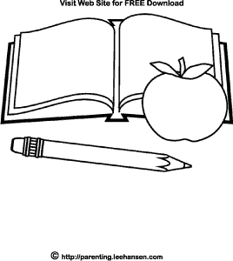
_____________________________________________________________________________________________________________________________________________________________________________________________________________________________________________________________________________________________________________________________________________________________________________________________________________________________________________________________________________________________________________________________________________________________________________________________________________________________________________________________________________________________________________________________________________________________________________________________________________________________________________________________________________________________________________________________________________________________________________
Series 3 (irregular verbs)

Begin (inf.)
Began (past)

Draw
Drew

Break
Broke

Drive
Drove

Give
Gave

Make
Made

Take
Took

Sing
Sang

Think
Thought

Run
Ran

Hear
Heard

Sleep
Slept
Practice your verbs

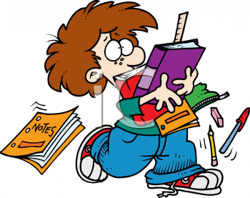

__________________________________________________________________________________________________________________________________________________________________________________________________________________________________________________________________________________________________________________________________________________________________________________________________________________________________________________________________________________________________________________________________________________________________________________________________________________________________________________________________________________________________________________________________________________________________________________________________________________________________________________________________________________________________________________________
Series 4 (irregular + regular verbs)

Buy
Bought

Fall
Fell

Catch
Caught

Hit
Hit

Read
Read

See
Saw

Sell
Sold

Swim
Swam

Wait
Waited

Laugh
Laughed

Ride
Rode

Stay
Stayed

Practice your verbs


________________________________________________________________________________________________________________________________________________________________________________________________________________________________________________________________________________________________________________________________________________________________________________________________________________________________________________________________________________________________________________________________________________________________________________________________________________________________________________________________________________________________________________________________________________________________________________________________________________________________________________

________________________________________________
Series 5 (irregular + regular verbs)

Bring (inf.)
Brought (past)

Cut
Cut

Cry
Cried

Get up
Got up

Jump
Jumped

Meet
Met

Move
Moved

Put
Put

Put
Put

Pull
Pulled

Push
Pushed
Push
Pushed

Visit
Visited

Wake up
Woke up
Practice your verbs


________________________________________________________________________________________________________________________________________________________________________________________________________________________________________________________________________________________________________________________________________________________________________________________________________________________________________________________________________________________________________________________________________________________________________________________________________________________________________________________________________________________________________________________________________________________________________________________________________________________________________________________________________________________________

List of extra irregular verbs
Be  Choose  Forget  Forgive  Have  Leave  Understand | Was Être  Chose Choisir  Forgot Oublier  Forgave Pardonner  Had Avoir  Left Partir  Understood Comprendre

Verb Index

Infinitive Past French

Series #1 Ask Asked Demander

Erase Erased Effacer

Explain Explained Expliquer

Listen Listened Écouter

Play Played Jouer

Scream Screamed Crier

Talk Talked Parler

Walk Walked Marcher

Want Wanted Vouloir

Watch Watched Observer

Whisper Whispered Chuchoter

Work Worked Travailler

Verb Index

Infinitive Past French

Series #2 Come Came Venir

Do Did Faire

Drink Drank Boire

Eat Ate Manger

Find Found Trouver

Go Went Aller

Lose Lost Perdre

Say Said Dire

Sit Down Sat Down S’asseoir

Stand up Stood up Se lever debout

Win Won Gagner

Write Wrote Écrire

Series #3 Begin Began Commencer

Break Broke Briser

Draw Drew Dessiner

Drive Drove Conduire

Give Gave Donner

Hear Heard Entendre

Make Made Faire

Run Ran Courir

Sleep Slept Dormir

Sing Sang Chanter

Take Took Prendre

Think Thought Penser

Verb Index

Infinitive Past French

Series #4 Buy Bought Acheter

Catch Caught Attraper

Fall Fell Tomber

Hit Hit Frapper

Laugh Laughed Rire

Ride Rode Se Promener

See Saw Voir

Sell Sold Vendre

Read Read Lire

Stay Stayed Rester

Swim Swam Nager

Wait Waited Attendre

Series #5 Bring Brought Apporter

Cry Cried Pleurer

Cut Cut Couper

Get up Got up Se lever

Jump Jumped Sauter

Meet Met Rencontrer

Pull Pulled Tirer

Push Pushed Pousser

Put Put Mettre

Visit Visited Visiter

Sleep Slept Dormir

Wake up Woke up Se réveiller

